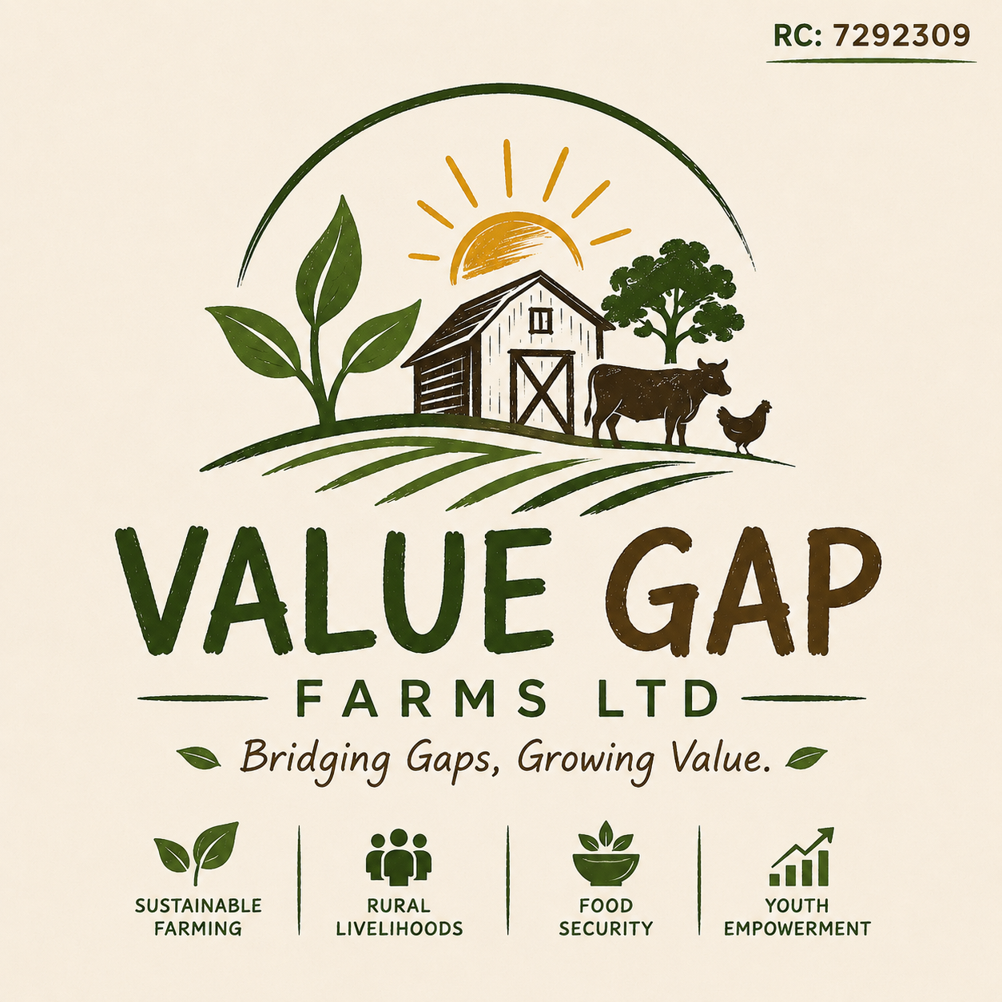
OFFICIAL INSTITUTIONAL PROFILE | GRANT DUE DILIGENCE DOSSIER
RC: 7292309 | AZARE, BAUCHI STATE, NIGERIA | VER: 2026.2
VALUE GAP FARMS NIGERIA LIMITED
Institutional Profile, Strategic Impact Plan & International Grant Due Diligence Pack
Executive Positioning: Value Gap Farms Nigeria Limited is an incorporated agricultural social enterprise combining high-efficiency commercial farming with community-driven rural development. Operating an integrated crop-livestock nucleus farm and smallholder outgrower network in Katagum LGA, Bauchi State, the company builds sustainable rural livelihoods, youth employment, and regional food security while maintaining full commercial self-sufficiency.

1. Enterprise At A Glance (Fiduciary & Legal Snapshot)
The following statutory profile provides international grantmakers, bilateral donors, and development finance institutions with verified organizational baseline data:
Due Diligence Parameter | Verified Enterprise Detail
Full Legal Name | Value Gap Farms Nigeria Limited
Corporate Affairs Commission (CAC) | Registered under the Companies and Allied Matters Act (RC: 7292309)
Date of Incorporation | January 9, 2024 (Active & In Good Standing)
Legal Entity Structure | Private Company Limited by Shares (Commercial Social Enterprise)
Tax Identification Number (TIN) | Active Federal Inland Revenue Service (FIRS) Registration
Anti-Money Laundering (AML/CFT) | Compliant with Special Control Unit Against Money Laundering (SCUML) guidelines
US Federal Grants / SAM.gov | SAM.gov Unique Entity Identifier (UEI) & NCAGE Code registered/ready for direct award eligibility
Registered Administrative Office | No. 119, Tafida Ali Street, Azare, Katagum LGA, Bauchi State, Nigeria
Farm Production Center | Katagum Agricultural Axis, Azare, Bauchi State, Nigeria
Banking & Disbursement Facility | Corporate Multi-Currency Domiciliary Banking (USD/GBP/EUR) with Tier-1 Nigerian Commercial Bank
Primary Value Chains | Crop Production (Rice, White Sorghum, Pearl Millet, Maize, Cowpea), Cattle Fattening, Animal Feed Milling
Target Donors & Grant Windows | USAID, USADF, UK FCDO, Australian Aid (DFAT), IFAD, AfDB ACFM, AECF, AGRA
2. Legal Basis & The Social Enterprise Model
2.1 Why a For-Profit Limited Structure Is Fundable by International Donors
A frequent question in development finance is whether a private company limited by shares is eligible for non-repayable grant funding. In international agricultural development, the answer is an emphatic YES. Bilateral donors (USAID, USADF, UK Aid/FCDO, Australia DFAT) and multilateral development institutions (IFAD, AfDB, World Bank) have recognized that traditional grant-dependent charities frequently collapse once donor disbursements cease.
Consequently, modern development funding heavily prioritizes Private Sector Engagement (PSE), Market Systems Development (MSD), and Blended Finance. Donors partner with commercially viable agricultural enterprises that operate with a deliberate social mission. Value Gap Farms Nigeria Limited exemplifies this model by deploying commercial revenue from grain sales, livestock fattening, and feed milling to create self-sustaining community benefits.
2.2 The Dual-Value Architecture (Commercial Engine + Social Purpose)
Value Gap Farms operates with two complementary engines:
- Commercial Engine: High-yield nucleus cultivation, mechanized tractor services, cattle fattening, and animal feed milling that generate market-driven revenues, cover operating expenses, and eliminate chronic reliance on charitable fundraising.
- Social Impact Mission: Aggregating smallholder outgrowers, providing zero-barrier access to mechanized plowing, distributing improved climate-resilient seeds, creating youth farm apprenticeships, and maintaining strict 40%+ women inclusion targets.
2.3 CAC Registered Objects & Strategic Focus
Value Gap Farms Nigeria Limited's Certified Extract from the Corporate Affairs Commission (Stamp Duty Cert. No: 2024-3279-3351169737, dated 09 January 2024) legally empowers the enterprise to conduct agricultural farming of all kinds, agro-mechanized farming, livestock and poultry production, cattle fattening, fertilizer production, animal feed milling, storage, and commodity marketing. The company's management purposefully concentrates capital and operational energy solely on agriculture, food security, and rural empowerment.
3. Geographic Footprint & Ecological Context
Value Gap Farms is strategically situated in Katagum Local Government Area (headquartered in Azare), in the northern ecological zone of Bauchi State, Nigeria. This region lies within the Sudan-Sahel Savannah agro-ecological corridor, characterized by vast fertile alluvial plains, semi-arid climatic cycles, and prominent smallholder farming communities.
Despite high agricultural potential, the Azare/Katagum agricultural corridor confronts distinct structural barriers that Value Gap Farms actively resolves:
- Climate Vulnerability: Erratic rainfall and prolonged dry seasons causing seasonal hunger and chronic rural underemployment.
- Post-Harvest Wastage: Up to 30% of harvested grains are lost annually due to rudimentary bag storage, pest infestation, and lack of modern drying equipment.
- Mechanization Deficit: Over 85% of smallholders rely on hand hoes, resulting in low crop yields, delayed planting, and severe physical fatigue.
- Youth Unemployment: Substantial rural youth migration to urban centers driven by the lack of profitable, modern agricultural employment.
4. Core Operations & Baseline Traction Data
Unlike exploratory paper concepts, Value Gap Farms is an actively operating agricultural enterprise with on-the-ground farmland, field workers, and livestock facilities.
4.1 Crop Production Portfolio
- Rice (Oryza sativa): Cultivation of high-yield swamp and upland varieties across irrigated lowland corridors.
- White Sorghum & Pearl Millet: Drought-tolerant white sorghum varieties providing essential food security and raw material for industrial malt/feed.
- Cowpea / Beans (Vigna unguiculata): High-protein legume cultivation supporting biological nitrogen fixation in soil and providing immediate household nutrition.
- Grain Maize: Yellow and white varieties cultivated with mechanized tractor-drawn seed drills and organic soil amendment.
4.2 Livestock & Cattle Fattening Operations
The enterprise operates a semi-intensive cattle feedlot facility in the Azare axis. Local indigenous breeds (White Fulani, Sokoto Gudali) are selected, placed under structured veterinary protocols (quarantine, deworming, vaccination), and fed formulated high-nutrition rations over structured 90- to 120-day cycles. This delivers high carcass quality for regional meat markets while generating valuable organic manure.
4.3 Circular Bio-Economy & Feed Milling
Value Gap Farms enforces a 100% closed-loop circular agriculture system:
- Waste-to-Feed:Crop residues (millet stalks, sorghum chaff, rice bran, cowpea haulms) are harvested, milled, and formulated with mineral premixes to produce cost-effective animal feed.
- Feed-to-Soil:100% of bovine and poultry manure is collected, cured, and reintroduced to crop fields as rich organic fertilizer, reducing dependence on expensive synthetic fertilizers and reversing soil degradation.
5. Theory of Change & Logical Framework (LogFrame)
Value Gap Farms adheres to a rigorous developmental Theory of Change aligning directly with bilateral donor priorities:
Identified Challenge | Intervention | Outputs (1-2 Yrs) | Outcomes | SDG Impact
1. Extreme Rural Poverty & Low Farm Incomes | Outgrower Aggregation & Market Off-take Guarantees | 500 smallholder farmers enrolled with direct market contracts | 45% average increase in smallholder net household income | SDG 1 (No Poverty)  SDG 8 (Decent Work)
2. Food Insecurity & Post-Harvest Losses (up to 30%) | Hermetic Grain Silo Storage & Solar Drying Hub | 2,000 MT grain storage capacity operational in Azare | Post-harvest grain loss reduced to under 5% | SDG 2 (Zero Hunger)  SDG 12 (Responsible Prod.)
3. Youth Unemployment & Economic Disenfranchisement | Youth Agricultural Mechanization & Tractor Apprenticeships | 100+ youth trained in mechanized farming and operations | 50 permanent and 150 seasonal wage-earning rural jobs | SDG 8 (Decent Work)  SDG 1 (No Poverty)
4. Climate Shocks & Dry-Season Inactivity | Solar-Powered Drip Irrigation & Water Conservation | Solar boreholes installed serving 50 hectares year-round | Double-crop cycles established; climate resilience secured | SDG 13 (Climate Action)  SDG 12 (Responsible Prod.)
6. Institutional Governance & Fiduciary Oversight
To eliminate key-person risk and ensure compliance with international donor fiduciary standards, Value Gap Farms operates under a dual-tier governance model comprising Executive Management and an independent Advisory Board.
6.1 Executive Management Team
- Founder & Managing Director (Halima Lele Muktar): Leads overarching corporate strategy, public sector linkages, investor relations, and institutional grant compliance. Oversees financial allocation and alignment with development goals.
- Co-Founder & Head of Farm Operations (Umar Lele Mukhtar): Directs field activities, tractor mechanization, farm labor management, crop cycles, cattle fattening feedlot protocols, and supply chain logistics across Azare.
- Senior Field Agronomist & Extension Lead: Leads agronomic research, soil health testing, seed variety trials, farmer extension services, and climate-smart training modules.
6.2 Advisory Board (Fiduciary & Community Oversight)
- 1. Senior Technical Agronomist (External Advisor): Provides independent technical review of crop yields, livestock health management, and climate-adaptation methodologies.
- 2. Financial Controller & Legal Governance Advisor: Ensures transparent bookkeeping, dual-signatory bank authorizations, tax compliance, and adherence to international grant accounting standards.
- 3. Community Outgrower & Cooperative Liaison: Facilitates ethical grassroots engagement, outgrower dispute resolution, fair wages, and inclusion of women farmer associations.
7. Standard Operating Policies (SOPs) & Fiduciary Standards
Value Gap Farms enforces written statutory policies designed to satisfy the strict pre-award due diligence requirements of the US Government (USAID/USADF), the UK Government (FCDO), and the Australian Government (DFAT):
7.1 Safeguarding & Child Protection Policy
Value Gap Farms strictly enforces zero tolerance for child labor across all nucleus fields, contract outgrower farms, and processing sites. All workers must meet legal age requirements. The company strictly implements Prevention of Sexual Exploitation, Abuse, and Harassment (PSEAH) protocols covering all employees, apprentices, and community beneficiaries.
7.2 Anti-Bribery & Anti-Corruption Policy
The company strictly complies with the Nigerian Corrupt Practices Act, the UK Bribery Act 2010, and the US Foreign Corrupt Practices Act (FCPA). Offering, soliciting, or accepting bribes, kickbacks, or illicit payments is unconditionally prohibited. Independent accounting audits ensure all project and grant disbursements are fully traceable to verified project expenses.
7.3 Gender Equality and Social Inclusion (GESI) Policy
Women smallholders are central to northern Nigerian agriculture but face chronic credit and input marginalization. Value Gap Farms mandates that at least 40% of all outgrower input packages, training allocations, and agro-processing opportunities are designated specifically for women farmers.
7.4 Environmental, Social & Climate Stewardship (ESG)
All farm operations strictly avoid bush burning, deforestation, and water table depletion. Crop-livestock circular recycling minimizes greenhouse gas emissions while rebuilding biological topsoil fertility across semi-arid terrains.
7.5 Whistleblowing & Grievance Redress Mechanism
A confidential grievance reporting channel (monitored by the independent Advisory Board at compliance@valuegapfarms.com) allows staff, outgrowers, and community members to report any safety, financial, or ethical irregularities without fear of retaliation.
8. Priority Grant Windows & Catalytic Funding Packages
Value Gap Farms has prepared modular, high-impact project packages ready for bilateral grant deployment:
Project Window | Scope & Technical Strategy | Grant Budget | Target Funders
Project 1: Solar-Powered Drip Irrigation Hub | Installation of deep solar boreholes, high-efficiency drip systems, and storage reservoirs to transition 50 hectares from single-season rainfed farming to continuous triple-crop vegetable and grain production. | $35,000 – $60,000 | USADF (via cooperative structures)
Project 2: Women & Youth Outgrower Revolving Fund | Provision of certified drought-resistant seed packs, biological inoculants, and mechanized plowing vouchers to 200 young and female smallholders, aggregated via guaranteed harvest buyback. | $25,000 – $50,000 | AGRA (2025 Smallholder Resilience Call), AfDB ACFM, IFAD Rural Youth
Project 3: Modern Grain Silo & Solar Cold Storage Hub | Construction of a centralized 1,000 MT hermetic grain preservation center in Azare to eliminate regional post-harvest grain losses and stabilize farm-gate prices for smallholders. | $50,000 – $100,000 | AECF Agri-Business
Project 4: Rural Mechanization Apprenticeship Academy | Procurement of 2 modern multi-functional tractors with planters and harvesters, coupled with an intensive technical training academy for 50 rural youth as commercial tractor operators and technicians. | $40,000 – $80,000 | USADF Agribusiness Grants, FCDO Skills Development
9. Virtual Data Room & Due Diligence Checklist
To facilitate accelerated compliance clearance by donor grant managers, the following institutional documents are held in our Virtual Due Diligence Data Room and are available upon formal request:
Due Diligence Document | Format / Issuing Authority
1. Certificate of Incorporation | CAC Form RC: 7292309 (Certified True Copy)
2. Certified Extract of Objects Clause | CAC Form CAC1.1 / Status Report confirming agricultural mandate
3. Tax Identification Number (TIN) | Federal Inland Revenue Service (FIRS) Registration Certificate
4. Anti-Money Laundering Compliance | Special Control Unit Against Money Laundering (SCUML) Documentation
5. SAM.gov Registration Profile | Unique Entity Identifier (UEI) & NCAGE Code Record (US Federal Grants)
6. Banking Reference & Proof of Account | Corporate Domiciliary (USD/EUR/GBP) Account Confirmation Letter
7. Land Tenure & Operational Location | Customary Land Title / Farmland Usage Agreements in Katagum LGA
8. Financial Records | Historical Management Accounts & Cash Flow Statements
9. Operational Media Dossier | High-Resolution Geotagged Photo & Video Repository of Farm Operations
10. Institutional Policies Manual | Full written texts of Safeguarding, Anti-Bribery, GESI, and ESG Policies
10. Institutional Partnerships & Grant Inquiries
Value Gap Farms Nigeria Limited welcomes engagement with international development agencies, philanthropic foundations, commercial off-takers, and academic research institutions.
- Official Institutional Email: partnerships@valuegapfarms.com / info@valuegapfarms.com
- Website & Operations Portal: https://valuegapfarms.com
- Headquarters: No. 119, Tafida Ali Street, Azare, Katagum LGA, Bauchi State, Nigeria
- Farm Operations Site: Katagum Agricultural Axis, Azare, Bauchi State, Nigeria
Value Gap Farms Nigeria Limited — Bridging Gaps, Growing Value.
Registered with the Corporate Affairs Commission (RC: 7292309)

